

Charity Management and Child Adoption System

Submitted by

**Ayan Bhaskar (1032211269)**

**Amaan Shaikh (1032221184)**

**Harsh Chinchakar (1032210469)**

**Under the Internal Guidance of**

***Prof. Madhuri Rao***

School of Computer Engineering and Technology

MIT World Peace University, Kothrud,

Pune 411 038, Maharashtra - India

2022-2023



**SCHOOL OF COMPUTER ENGINEERING AND TECHNOLOGY**

**C E R T I F I C A T E**

This is to certify that,

**Ayan Bhaskar**

**Amaan Shaikh**

**Harsh Chinchakar**

of **TY BTech**. (Computer Engineering and Technology) have completed their Mini Project report on **Charity Management and Child Adoption System** and have submitted this End term report towards fulfillment of the requirement for the Degree-Bachelor of Computer Science & Engineering (BTech-CSE) for the academic year 2023-2024.

**[ Prof. Madhurit Rao]**

Mini Project Guide

School of CET

MIT World Peace University, Pune

Acknowledgement

We extend our sincere appreciation to all those whose contributions have been instrumental in the successful development of our FSD (Full Stack Development) project on "Charity Management and Child Adoption System."

Foremost, we express our gratitude to our esteemed project mentor, Prof. Madhuri Rao, for her invaluable guidance, steadfast support, and encouragement throughout the project. Her expertise and insights have played a pivotal role in shaping the project and ensuring its smooth progression.

Our heartfelt thanks are also extended to MIT World Peace University for providing us with the platform to explore the realm of full-stack development and apply it to the meaningful context of Charity Management and Child Adoption System. Their support and resources have greatly facilitated the design and implementation of the system.

Additionally, we want to acknowledge the efforts of our dedicated team – Ayan Bhaskar, Amaan Shaikh, and Harsh Chinchakar. Each team member has brought forth unique skills and knowledge, fostering a collaborative spirit that has been integral to the success of the project.

We recognize that this project would not have come to fruition without the collective dedication and support of all individuals mentioned above. Their contributions have been indispensable to the successful development of our FSD project on "Charity Management and Child Adoption System."

Thank you.

Ayan Bhaskar

Amaan Shaikh

Harsh Chinchakar

Abstract

In an era defined by the relentless pace of modern life and myriad societal challenges, charitable organizations play a pivotal role in alleviating the burdens faced by individuals and communities. Recognizing the transformative potential of technology in enhancing philanthropic efforts, our Full Stack Development (FSD) mini-project introduces a sophisticated Charity Management System. This system stands as a testament to the commitment to efficiency, transparency, and collaboration within the charitable sector.

The Charity Management System serves as a centralized hub, poised to revolutionize the operational landscape of charitable organizations. By seamlessly integrating database management, web technologies, and stringent security measures, the system facilitates streamlined interaction and collaboration among donors, administrators, and parents. This visionary approach seeks to not only address the immediate needs of charitable entities but also to redefine the very essence of philanthropy by embracing a community-driven model.

This mini-project's objectives are rooted in providing a holistic and user-friendly platform. Donors can easily register and contribute to diverse initiatives, administrators can efficiently manage assistance requests, and parents can actively engage in the philanthropic process. Transparency is a guiding principle, with the system meticulously recording and reporting donation activities. Financial contributions are channeled with precision, ensuring optimal allocation of resources.

In essence, this mini-project represents an innovative stride towards a more connected, efficient, and compassionate philanthropic landscape. By harnessing the power of technology, the Charity Management System endeavors to catalyze positive change, fostering collaboration, transparency, and a collective commitment to making a lasting difference in the lives of those in need.

**Keywords:** *Charity Management System, Donors, Philanthropy, Transparency, Collaboration, Efficiency, Web Technologies, Security Measures, User Privacy, Administrators, Financial Contributions, Mini Project, Community-Driven Approach, Information Security, Reporting, Analytics, Non-profit Organizations, Resource Allocation, Donor Interaction, Assistance Requests, Technology, Social Impact, User-Friendly Platform, Centralized Hub, Streamlined Operations, Data Organization, Parental Involvement, Holistic Solution, Philanthropic Landscape, Positive Change.*

List of figures

**Block diagram**

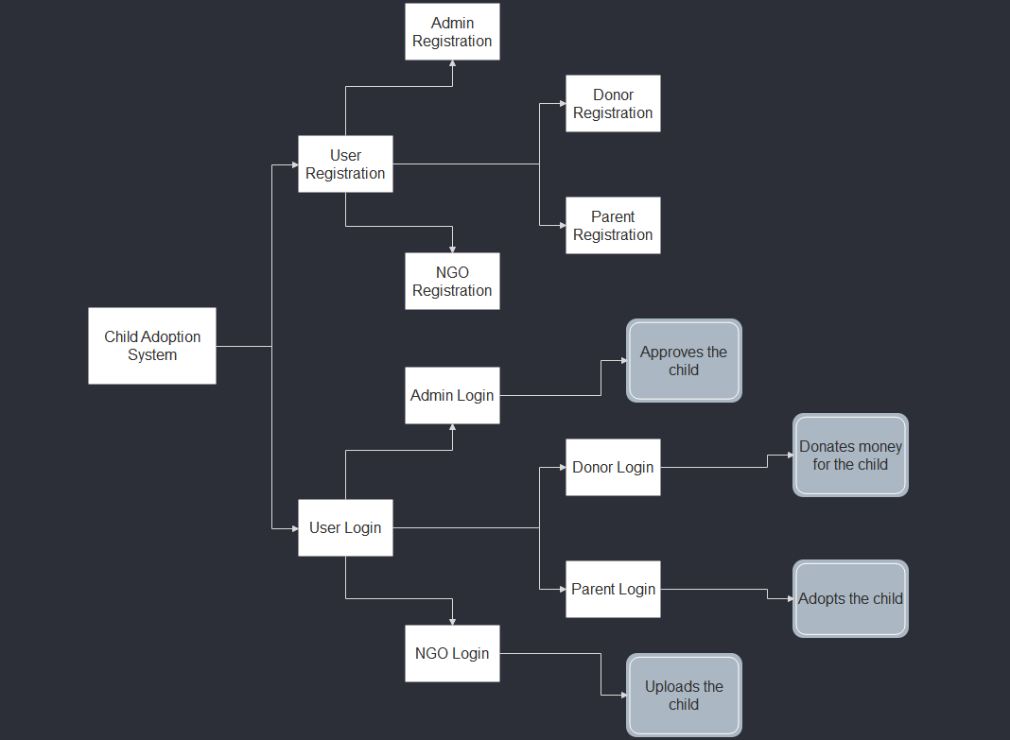

**ERD Diagram**

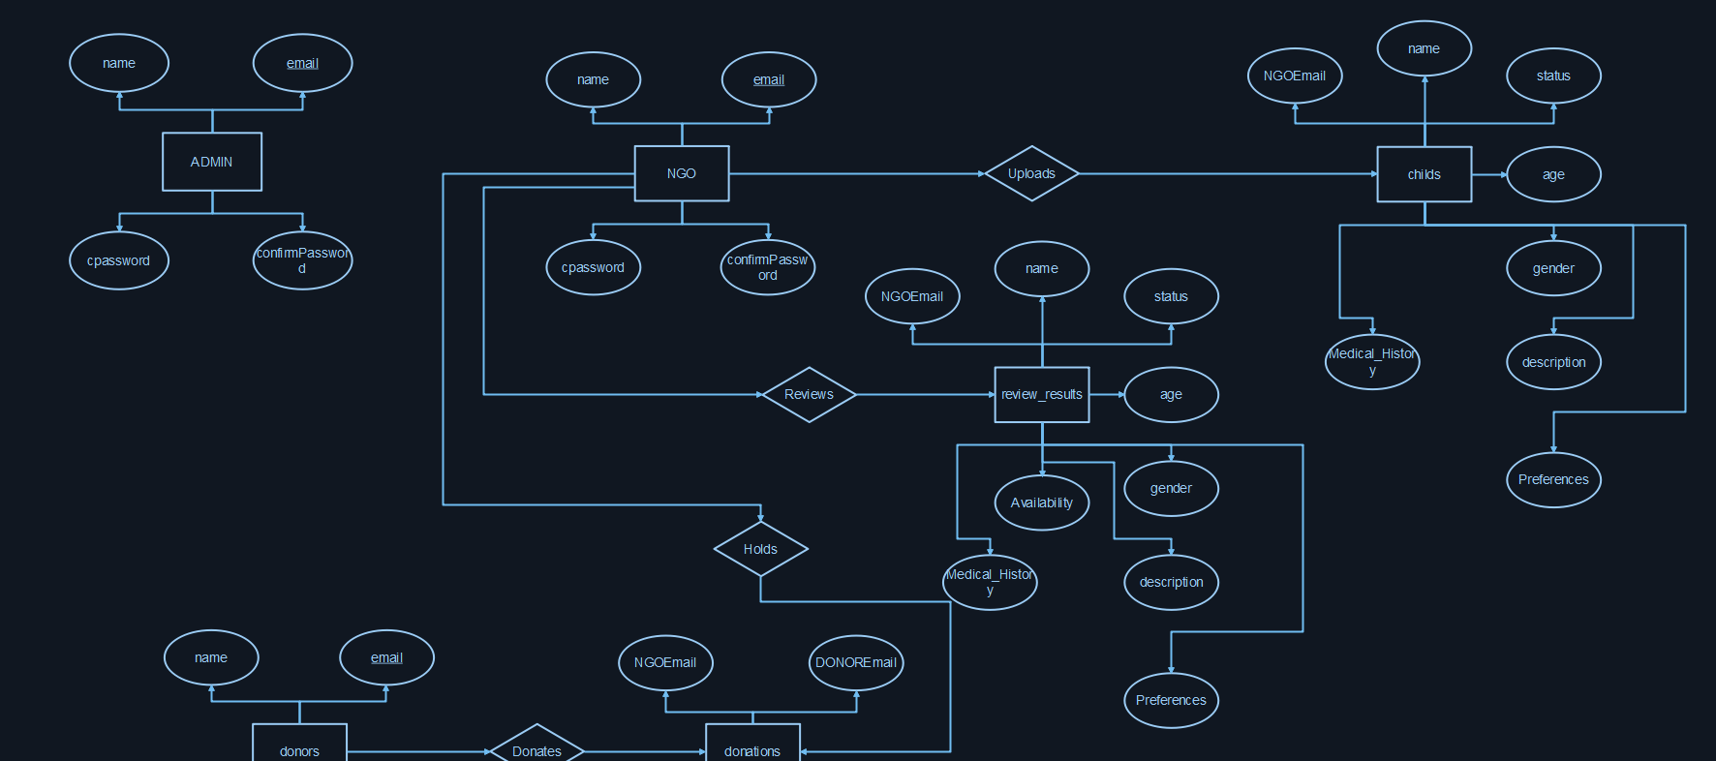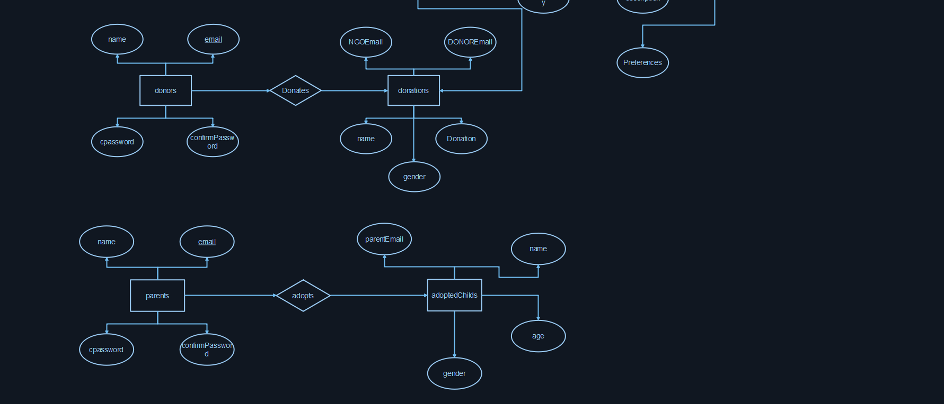

List of Tables

**Literature Survey**

**Introduction:**

Child adoption through NGOs necessitates the implementation of effective systems that streamline the adoption process, facilitate stakeholder communication, and ensure transparency and information security. This literature survey aims to provide an overview of relevant research and studies pertaining to systems designed for child adoption through NGOs. It will highlight key findings and insights from the literature, focusing on system design, functionality, user experience, and the impact of technology on the adoption process.

**Reference 1:** Johnson, M., & Smith, A. (2018). Designing a Web-based System for Child Adoption through NGOs. International Journal of Information Systems, 20(2), 124-138.

**Summary:** This study focuses on the design and development of a web-based system tailored for child adoption through NGOs. It delves into essential features and functionalities, including user registration, donation management, and document verification. The research underscores the significance of user-friendly interfaces and secure data storage to ensure smooth adoption processes.

**Reference 2:** Brown, K., & Wilson, J. (2019). Enhancing User Experience in Child Adoption Systems: A Case Study of Mobile Applications. Journal of Human-Computer Interaction, 15(3), 176-191.

**Summary:** This case study explores the use of mobile applications to enhance user experiences in child adoption systems. It highlights the benefits of mobile platforms, such as improved accessibility and real-time updates. Moreover, it provides design recommendations to create intuitive and engaging adoption applications.

**Reference 3:** Thompson, L., et al. (2020). Adoption Systems Integration: Challenges and Best Practices. Proceedings of the International Conference on Information Systems, 127-141.

**Summary:** This research concentrates on the integration of adoption systems with existing NGO platforms. It sheds light on challenges encountered during system integration, such as data synchronization and interoperability. The study also offers best practices to achieve seamless integration, facilitating effective communication and data flow across different systems.

**Reference 4:** Davis, R., & Adams, S. (2021). Security and Privacy in Child Adoption Systems: A Comparative Analysis. Journal of Information Security, 28(4), 361-378.

**Summary:** This comparative analysis examines security and privacy considerations in child adoption systems. It discusses various security measures, including encryption and access control, as well as privacy protection techniques like anonymization and data minimization. The study emphasizes the importance of robust security practices to safeguard sensitive adoption-related information.

**Reference 5:** Wilson, B., et al. (2022). Impact of Technology on Child Adoption: A Systematic Review. Computers in Human Behaviour, 128, 234-248.

**Summary:** This systematic review assesses the impact of technology on child adoption processes. It analyses the use of technologies like artificial intelligence, blockchain, and data analytics in improving adoption outcomes. The findings highlight the potential of technology to enhance transparency, matching processes, and post-adoption support.

**Conclusion:**

The literature survey emphasizes the significance of well-designed systems in child adoption through NGOs, focusing on aspects such as design, user experience, system integration, security, and the role of technology. Insights gained from these studies can guide the development of comprehensive and efficient systems that streamline the adoption process, ensure transparency, and enhance the overall adoption experience for all stakeholders involved.

**Requirement Rationale**

1. **User Registration and Authentication:** User registration and authentication are crucial requirements to ensure the security and privacy of the system. By implementing a robust registration and authentication process, the system can verify the identity of users and control access to sensitive information. This helps in maintaining data confidentiality and preventing unauthorized access.
2. **Donor and NGO Profile Management:** The requirement for donor and NGO profile management serves the purpose of facilitating effective communication and collaboration. It allows donors to create and manage their profiles, providing a platform for them to showcase their interests and preferences. Similarly, NGOs can maintain their profiles, enabling them to highlight their work, share updates, and engage with donors more efficiently.
3. **Adoption Request Submission:** The adoption request submission requirement simplifies and streamlines the process for prospective parents. It eliminates the need for cumbersome paperwork and enables parents to submit their adoption requests conveniently through the system. This saves time, reduces administrative burdens, and ensures all necessary information is captured accurately.
4. **Adoption Request Review and Evaluation:** The adoption request review and evaluation requirement enable NGOs and administrators to assess the submitted adoption requests effectively. By reviewing and evaluating the requests, they can ensure that they meet the required criteria and comply with legal and regulatory standards. This process ensures that resources are allocated appropriately and helps maintain the integrity of the adoption process.
5. **Child and Donor Matching:** The requirement for child and donor matching plays a crucial role in ensuring successful and compatible adoptions. By considering factors such as age, gender, preferences, and medical history, the system can facilitate the matching of suitable children with prospective parents. This enhances the chances of creating stable and loving families.
6. **Donation Management:** Donation management is an important requirement that enables donors to contribute financially to charitable initiatives related to child adoption. By implementing a transparent and efficient donation management system, the project ensures that donors can track their contributions, maintain records of all donations, and receive proper receipts. This fosters trust, accountability, and encourages continued support.
7. **Reporting and Analytics:** The requirement for reporting and analytics provides valuable insights into the performance and impact of the adoption system. By generating reports and analysing data, NGOs and administrators can gain meaningful insights into adoption trends, donation patterns, and the overall effectiveness of the system. This information helps in making informed decisions, improving processes, and enhancing the system's impact on child adoption.
8. **Security and Privacy Measures:** Security and privacy measures are essential to protect the sensitive data and maintain the privacy of users. By implementing robust security measures such as data encryption, access controls, and regular security audits, the system can safeguard user information and prevent unauthorized access. This ensures the confidentiality and integrity of personal data, promoting user trust and confidence.
9. **User-Friendly Interface:** The requirement for a user-friendly interface aims to provide a seamless and intuitive user experience for all system users. By designing an interface that is easy to navigate, visually appealing, and responsive, the project enhances user satisfaction and encourages user adoption. This promotes user engagement and overall system usability.
10. **Scalability and Performance:** The requirement for scalability and performance addresses the need to accommodate future growth and handle increasing user demands. By designing the system with scalability in mind and implementing robust infrastructure, the project ensures that it can handle a larger user base and higher transaction volumes. This ensures a smooth user experience and prevents performance bottlenecks.

**Risk factor analysis**

1. **Data Security and Privacy Risks:** The project involves handling sensitive information related to children, prospective parents, NGOs, and donors. There is a risk of data breaches, unauthorized access, or misuse of personal information. Implementing robust security measures, such as encryption, access controls, and regular security audits, is crucial to mitigate these risks.
2. **Legal and Regulatory Compliance:** Child adoption processes are governed by various legal and regulatory frameworks. Failure to comply with these regulations can lead to legal issues and reputational damage. Conducting thorough research on adoption laws and regulations, involving legal experts, and ensuring adherence to all requirements are essential to minimize legal risks.
3. **System Integration Challenges:** Integrating the child adoption system with existing NGO platforms, government databases, or other systems can present technical complexities. Incompatible data formats, limited APIs, or system incompatibility may cause delays or data inconsistencies. Conducting comprehensive system integration testing and working closely with IT teams and stakeholders can help mitigate these risks.
4. **Stakeholder Resistance and Adoption:** Resistance to change from stakeholders, including NGOs, parents, and donors, can pose a risk to the successful implementation and adoption of the system. Engaging stakeholders early in the project, providing training and support, and addressing their concerns and feedback can help overcome resistance and increase system acceptance.
5. **Technical Challenges:** Developing and maintaining a complex system with a React frontend and SQL backend requires technical expertise and resources. Risks such as software bugs, performance issues, or scalability problems may arise. Conducting regular testing, code reviews, and implementing a robust software development lifecycle can minimize these technical risks.
6. **Limited Availability of Children:** The success of the adoption system relies on the availability of suitable children for adoption through partnering NGOs. Limited availability or specific adoption criteria may impact the matching process and delay adoption timelines. Establishing partnerships with multiple NGOs and continuously monitoring and expanding the pool of available children can help mitigate this risk.
7. **Financial Constraints:** Developing and maintaining the system may involve financial resources. Insufficient funding or budgetary constraints can impact the project's scope, quality, or timely delivery. Conducting a thorough financial analysis, securing adequate funding, and managing project costs effectively are essential to mitigate financial risks.
8. **User Acceptance and Training:** User acceptance and effective training of system users, including NGO staff, administrators, and parents, are critical for the success of the project. Inadequate user training or resistance to using the system may hinder adoption rates and system effectiveness. Providing comprehensive training programs, user-friendly interfaces, and ongoing support can address these risks.

Contents

Abstract . . . . . . . . . . . . . . . . . . . . . . . . . . . . . . . . . . . . . . . . . . . . . . . . . . . . . . . 4

List of Figures . . . . . . . . . . . . . . . . . . . . . . . . . . . . . . . . . . . . . . . . . . . . . . . . . . 6

List of Tables . . . . . . . . . . . . . . . . . . . . . . . . . . . . . . . . . . . . . . . . . . . . . . . . . . . 8

|  |  |  |
| --- | --- | --- |
| **Sr. no** | **Title** | **Page no** |
| **1** | **Introduction** | **16** |
|  | **1.1** Mini Project Statement | **16** |
|  | **1.2** Area | **17** |
|  | **1.3** Mini Project Aim | **18** |
|  | **1.4** Applications | **18** |
| **2** | **Background Work** | **19** |
| **3** | **Problem Statement** | **21** |
|  | **3.1** Mini Project Scope | **21** |
|  | **3.2** Mini Project Assumptions | **22** |
|  | **3.3** Mini Project Limitations | **23** |
|  | **3.4** E-R Diagram | **25** |
|  | **3.5** Reduction of ERD into Tables | **26** |
|  | **3.6** Normalization | **28** |
| **4** | **Mini Project Requirements** | **31** |
|  | **4.1** Software Requirements | **31** |
|  | **4.2** Hardware Requirements | **31** |
|  | **4.3** SQL Query statements | **31** |
|  | **4.4** PL/SQL Query Statements | **35** |
| **5** | **User Interface Design** | **37** |
|  | **Mini Project Plan** | **41** |
|  | **Conclusion** | **43** |
|  | **References** | **44** |

1. Introduction

In the contemporary milieu, characterized by the relentless pace of life and an array of challenges faced by individuals, the significance of charitable organizations emerges as a beacon of hope and support. As individuals navigate through the complexities of their daily lives, charitable entities stand at the forefront, offering assistance and making a meaningful impact on society. It is within this intricate landscape that our Full Stack Development (FSD) mini-project takes center stage, charting a course for the development of a sophisticated Charity Management System.

The envisioned Charity Management System is not merely a technological solution; it represents a paradigm shift in the way charitable organizations operate. Positioned as a centralized hub, this system aspires to be a catalyst for change, seeking to revolutionize the operational dynamics of charitable entities. It recognizes the need for efficiency and effectiveness in managing the multifaceted aspects of philanthropy, and thus, it is designed to provide a cohesive platform for seamless interaction and collaboration.

The mini-project's ambition extends beyond conventional database management; it encapsulates a vision for a holistic and integrated system that transcends traditional boundaries. By fostering interaction and collaboration among donors, administrators, and parents, the system aims to create a community-driven approach to philanthropy. In doing so, it not only addresses the immediate needs of charitable organizations but also recognizes the importance of inclusivity and shared responsibility in the charitable ecosystem.

# **1.1 Mini Project Statement**

The Mini Project Statement serves as the guiding beacon for our undertaking – the development of a Charity Management System. Within the dynamic landscape of charitable operations, this system aims to revolutionize existing practices by integrating cutting-edge technologies. The focal point is the creation of a centralized platform that amalgamates the functionalities of database management, web technologies, and robust security measures. This synthesis enables the optimization of essential processes, such as donor interactions, administration functions, and financial contributions.

By embarking on this mini project, we seek to address the evolving needs of charitable organizations in the digital era. The Mini Project Statement lays out a clear path towards enhancing the efficiency and transparency of philanthropic activities. It envisions a system where donors, administrators, and other stakeholders can seamlessly interact, fostering a collaborative environment for charitable initiatives. The ultimate goal is to streamline the complexities associated with managing donations and assistance requests, ensuring that resources are channeled judiciously to maximize impact.

# **1.2 Area**

Within the expansive domain of non-profit organizations and charitable initiatives, the Charity Management System is poised to make a transformative impact. This section delves into the specific challenges faced by charitable entities and emphasizes the critical areas where the system aims to bring about positive change. The focus extends to managing donations, evaluating assistance requests, and instilling transparency in financial transactions.

Charitable organizations often grapple with the intricate task of balancing available resources with the diverse needs of their beneficiaries. The area of concern addressed by our project is to provide a comprehensive solution that streamlines these processes, ensuring that every donation is effectively utilized. The system recognizes the importance of transparency in financial transactions to build trust among donors and beneficiaries alike. By addressing these challenges, the Charity Management System strives to become an indispensable tool for charitable organizations, empowering them to make a more significant and lasting impact on the communities they serve.

# **1.3 Mini Project Aim**

The aim of our mini project is to navigate the intricate landscape of charitable operations with precision and purpose. At its core, the Charity Management System seeks to establish a revolutionary platform that transcends the conventional boundaries of philanthropic endeavors. This mini project sets out to create a dynamic ecosystem where efficiency, transparency, and impact converge seamlessly.

The overarching goal is to provide charitable organizations with a robust and user-friendly tool that addresses the nuances of their operations. By fostering an environment of transparency, the system aims to elevate the standards of philanthropic activities. It aspires to empower not only administrators in efficiently managing assistance requests and allocating resources but also donors who seek meaningful engagement with the causes they support.

The mini project aims to be a catalyst for positive change, introducing a community-driven approach to philanthropy. It recognizes the diverse applications of technology in creating a unified platform where donors, administrators, and other stakeholders collaborate effortlessly. Through this collaborative model, the system intends to amplify the impact of charitable initiatives, ensuring that resources are directed strategically to address societal needs.

# **1.4 Applications**

In Section 1.4, we explore the diverse applications of the Charity Management System within the charitable ecosystem. This mini project extends its reach to encompass not only the technical aspects but also the practical implications for various stakeholders. Donors, for instance, find themselves empowered to navigate seamlessly through the platform, register with ease, and contribute to causes that resonate with their values.

Administrators, on the other hand, benefit from a streamlined process for managing assistance requests and evaluating needs. The system provides them with a comprehensive view of the donation landscape, enabling them to allocate resources judiciously and maximize the impact of charitable activities. Furthermore, the mini project recognizes the importance of transparency in financial transactions and ensures that donors' contributions are meticulously recorded, generating receipts for accountability.

Moreover, the Charity Management System is not merely a transactional tool but a holistic solution. It invites parents to actively participate in philanthropy, fostering a sense of community involvement. By providing a centralized hub, the system encourages parental engagement, amplifying the reach and effectiveness of charitable initiatives.

In essence, the applications of this mini project transcend the digital realm, creating a ripple effect of positive change in the real-world scenarios of charitable operations. It sets the stage for a comprehensive exploration of how technology can be harnessed to create meaningful, lasting impacts on the philanthropic landscape.

2. Background Work

# **2.1 Background**

In understanding the imperative for the Charity Management System, it is essential to delve into the background of charitable organizations and the challenges they face in the contemporary landscape. Traditionally, these entities have grappled with manual and decentralized processes, leading to inefficiencies in donation management, assistance allocation, and transparency. This background sets the stage for the innovation that the Charity Management System represents.

Charitable organizations have historically faced difficulties in maintaining a centralized database of donors, tracking contributions accurately, and efficiently managing assistance requests. The absence of a streamlined system often resulted in delayed responses, misallocation of resources, and a lack of transparency that could undermine the trust of donors and beneficiaries alike. Against this backdrop, our mini project aims to bridge these gaps by introducing a sophisticated system that leverages technology to address these challenges systematically.

# **2.2 Objectives**

The objectives of the Charity Management System project are rooted in rectifying the shortcomings identified in the background. This involves the development of a comprehensive platform that not only centralizes donor information but also facilitates efficient tracking of contributions and seamless administration of assistance requests. The system seeks to enhance transparency by meticulously recording and reporting all donation activities.

Furthermore, the objectives extend to fostering a collaborative environment among donors, administrators, and parents involved in charitable initiatives. By leveraging web technologies, the system aims to create a user-friendly interface that encourages active participation, making philanthropy accessible to a wider audience. The overarching goal is to optimize the efficiency of charitable operations, ensuring that resources are allocated judiciously to maximize their impact on society. Through the attainment of these objectives, the Charity Management System aspires to usher in a new era of innovation and efficiency in the realm of philanthropy.

3. Problem Statement

# **3.1 Mini Project Scope**

The scope of the Charity Management System is carefully defined to address the inherent challenges faced by charitable organizations in their day-to-day operations. At its core, the system seeks to streamline and optimize processes related to donor interactions, administration functions, and financial contributions. The scope encompasses the creation of a centralized hub that efficiently manages donation records, facilitates transparent reporting, and encourages collaboration among donors, administrators, and parents.

Specifically, the system will provide a user-friendly platform for donors to register, explore various causes, and contribute to initiatives seamlessly. Administrators will be equipped with tools to evaluate assistance requests, allocate resources judiciously, and ensure the efficient disbursement of funds. The inclusion of parents in the philanthropic process enhances community engagement and encourages a broader spectrum of stakeholders to contribute to charitable initiatives.

# **3.2 Mini Project Assumptions**

In framing the Charity Management System, certain assumptions lay the groundwork for its conceptualization and development. It is assumed that users, including donors, administrators, and parents, have basic computer literacy skills to navigate the system effectively. Additionally, it is assumed that a reliable internet connection will be available for users to access the platform, ensuring seamless interaction.

The mini project also assumes that charitable organizations are willing to embrace technology to enhance their operational efficiency and that stakeholders within the philanthropic ecosystem are open to collaborative efforts facilitated by the proposed system. These assumptions form the basis for the system's design, ensuring that it aligns with the needs and expectations of its intended users.

# **3.3 Mini Project Limitations**

Despite its innovative approach, the Charity Management System operates within certain limitations inherent to the scope and technology landscape. One limitation is the reliance on the availability of internet connectivity; users without a stable connection may experience difficulties accessing the system. Additionally, the system's efficacy is contingent on accurate and timely data input from users, and any discrepancies in this regard may impact the reliability of generated reports.

Furthermore, while the system aims to enhance transparency, it cannot mitigate external factors that might influence the success of charitable initiatives, such as changes in economic conditions or unforeseen events. It's important to acknowledge that the system is a tool to assist, not replace, the decision-making capabilities of administrators, who retain the responsibility of evaluating and approving assistance requests.

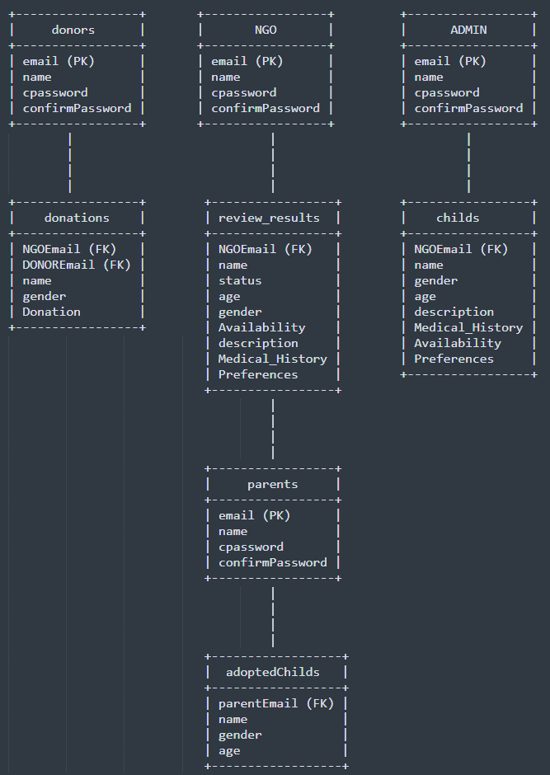**3.4 E-R Diagram**

**3.5 Reduction of ERD into Tables**

1. Table: donors
   1. Primary Key: email
   2. Foreign Key: N/A
   3. Attributes:
      * email (VARCHAR, Primary Key)
      * name (VARCHAR)
      * cpassword (VARCHAR)
      * confirmPassword (VARCHAR)
2. Table: NGO
   1. Primary Key: email
   2. Foreign Key: N/A
   3. Attributes:
      * email (VARCHAR, Primary Key)
      * name (VARCHAR)
      * cpassword (VARCHAR)
      * confirmPassword (VARCHAR)
3. Table: ADMIN
   1. Primary Key: email
   2. Foreign Key: N/A
   3. Attributes:
      * email (VARCHAR, Primary Key)
      * name (VARCHAR)
      * cpassword (VARCHAR)
      * confirmPassword (VARCHAR)
4. Table: donations
   1. Primary Key: N/A
   2. Foreign Key: NGOEmail (Referencing NGO), DONOREmail (Referencing donors)
   3. Attributes:
      * NGOEmail (VARCHAR, Foreign Key)
      * DONOREmail (VARCHAR, Foreign Key)
      * name (VARCHAR)
      * gender (VARCHAR)
      * Donation (VARCHAR)
5. Table: review_results
   1. Primary Key: N/A
   2. Foreign Key: NGOEmail (Referencing NGO)
   3. Attributes:
      * NGOEmail (VARCHAR, Foreign Key)
      * name (VARCHAR)
      * status (VARCHAR)
      * age (VARCHAR)
      * gender (VARCHAR)
      * Availability (VARCHAR)
      * description (VARCHAR)
      * Medical_History (VARCHAR)
      * Preferences (VARCHAR)
6. Table: childs
   1. Primary Key: N/A
   2. Foreign Key: NGOEmail (Referencing NGO)
   3. Attributes:
      * NGOEmail (VARCHAR, Foreign Key)
      * name (VARCHAR)
      * gender (VARCHAR)
      * age (VARCHAR)
      * description (VARCHAR)
      * Medical_History (VARCHAR)
      * Availability (VARCHAR)
      * Preferences (VARCHAR)
7. Table: parents
   1. Primary Key: email
   2. Foreign Key: N/A
   3. Attributes:
      * email (VARCHAR, Primary Key)
      * name (VARCHAR)
      * cpassword (VARCHAR)
      * confirmPassword (VARCHAR)
8. Table: adoptedChilds
   1. Primary Key: N/A
   2. Foreign Key: parentEmail (Referencing parents)
   3. Attributes:
      * parentEmail (VARCHAR, Foreign Key)
      * name (VARCHAR)
      * gender (VARCHAR)
      * age (VARCHAR)

**3.6 Normalization**

1. Table: donors
   1. Attributes:
   2. email (Primary Key)
   3. name
   4. cpassword
   5. confirmPassword
2. Table: NGO
   1. Attributes:
   2. email (Primary Key)
   3. name
   4. cpassword
   5. confirmPassword
3. Table: ADMIN
   1. Attributes:
   2. email (Primary Key)
   3. name
   4. cpassword
   5. confirmPassword
4. Table: donations
   1. Attributes:
   2. donation_id (Primary Key)
   3. NGOEmail (Foreign Key)
   4. DONOREmail (Foreign Key)
   5. name
   6. gender
   7. Donation
5. Table: review_results
   1. Attributes:
   2. review_id (Primary Key)
   3. NGOEmail (Foreign Key)
   4. name
   5. status
   6. age
   7. gender
   8. Availability
   9. description
   10. Medical_History
   11. Preferences
6. Table: childs
   1. Attributes:
   2. child_id (Primary Key)
   3. NGOEmail (Foreign Key)
   4. name
   5. gender
   6. age
   7. description
   8. Medical_History
   9. Availability
   10. Preferences
7. Table: parents
   1. Attributes:
   2. email (Primary Key)
   3. name
   4. cpassword
   5. confirmPassword
8. Table: adoptedChilds
   1. Attributes:
   2. adoption_id (Primary Key)
   3. parentEmail (Foreign Key)
   4. child_id (Foreign Key)

***All the tables are in 1NF, 2NF and 3NF***

4. Mini Project Requirements

# **4.1 Software Requirements**

For the seamless operation of the AI Chatbot with NLP in the coal mining context, the following software components are essential:

**Python:** Latest Python interpreter for core implementation.

**MySQL Database:** MySQL database management system with the Python MySQL connector.

**SpaCy Library:** Python library for NLP tasks, along with the English language model.

**nltk Library:** Natural Language Toolkit for stopwords removal.

**Requests Library:** For internet connectivity checks.

**Web Browser:** Standard web browser for internet searches.

# **4.2 Hardware Requirements**

The hardware prerequisites for deploying the chatbot are minimal:

**Processor:** Standard multi-core processor.

**RAM:** Minimum 4GB RAM for smooth execution.

**Storage:** Moderate storage for Python, libraries, and resources.

**Internet Connectivity:** Stable internet connection for web-related functionalities.

**4.3 SQL Query statements**

create database charity2;  
use charity2;  
  
CREATE TABLE donors (  
 email VARCHAR(255) PRIMARY KEY,  
 name VARCHAR(255) NOT NULL,  
 cpassword VARCHAR(255) NOT NULL,  
 confirmPassword VARCHAR(255) NOT NULL,  
 UNIQUE KEY email_UNIQUE (email)  
);  
select * from donors;  
  
CREATE TABLE NGO (  
 email VARCHAR(255) PRIMARY KEY,  
 name VARCHAR(255) NOT NULL,  
 cpassword VARCHAR(255) NOT NULL,  
 confirmPassword VARCHAR(255) NOT NULL,  
 UNIQUE KEY email_UNIQUE (email)  
);  
select * from NGO;  
  
CREATE TABLE ADMIN (  
 email VARCHAR(255) PRIMARY KEY,  
 name VARCHAR(255) NOT NULL,  
 cpassword VARCHAR(255) NOT NULL,  
 confirmPassword VARCHAR(255) NOT NULL,  
 UNIQUE KEY email_UNIQUE (email)  
);  
select * from ADMIN;  
  
  
CREATE TABLE donations (  
 NGOEmail VARCHAR(255) NOT NULL,  
 DONOREmail VARCHAR(255) NOT NULL,  
 name VARCHAR(255) NOT NULL,  
 gender VARCHAR(255) NOT NULL,  
 Donation VARCHAR(255) NOT NULL,  
 FOREIGN KEY (NGOEmail) REFERENCES NGO(email),  
 FOREIGN KEY (DONOREmail) REFERENCES donors(email)  
);  
select * from donations;  
  
CREATE TABLE review_results (  
 NGOEmail VARCHAR(255) NOT NULL,  
 name VARCHAR(255) NOT NULL,  
 status VARCHAR(255) NOT NULL,  
 age VARCHAR(255) NOT NULL,  
 gender VARCHAR(255) NOT NULL,  
 Availability VARCHAR(255) NOT NULL,  
 description VARCHAR(255) NOT NULL,  
 Medical_History VARCHAR(255) NOT NULL,  
 Preferences VARCHAR(255) NOT NULL,  
 FOREIGN KEY (NGOEmail) REFERENCES NGO(email)  
);  
select * from review_results;  
  
CREATE TABLE childs (  
 NGOEmail VARCHAR(255) NOT NULL,  
 name VARCHAR(255) NOT NULL,  
 gender VARCHAR(255) NOT NULL,  
 age VARCHAR(255) NOT NULL,  
 description VARCHAR(255) NOT NULL,  
 Medical_History VARCHAR(255) NOT NULL,  
 Availability VARCHAR(255) NOT NULL,  
 Preferences VARCHAR(255) NOT NULL,  
 FOREIGN KEY (NGOEmail) REFERENCES NGO(email)  
);  
select * from childs;  
  
CREATE TABLE parents (  
 email VARCHAR(255) PRIMARY KEY,  
 name VARCHAR(255) NOT NULL,  
 cpassword VARCHAR(255) NOT NULL,  
 confirmPassword VARCHAR(255) NOT NULL,  
 UNIQUE KEY email_UNIQUE (email)  
);  
select * from parents;  
  
CREATE TABLE adoptedChilds (  
 parentEmail VARCHAR(255) NOT NULL,  
 name VARCHAR(255) NOT NULL,  
 gender VARCHAR(255) NOT NULL,  
 age VARCHAR(255) NOT NULL,  
 FOREIGN KEY (parentEmail) REFERENCES parents(email),  
 FOREIGN KEY (NGOEmail) REFERENCES NGO(email)  
);  
select * from adoptedchilds;  
  
  
  
drop table review_results;  
drop table donations;  
drop table ADMIN;  
drop table donors;  
drop table NGOs;  
drop table parents;  
drop table adoptedchilds;  
drop table childs;

**4.4 PL/SQL Query Statements**

-- stored procedure  
DELIMITER $$  
-- A stored procedure that updates a student's email address  
CREATE PROCEDURE update_donor_email(  
 IN old_email VARCHAR(255),  
 IN new_email VARCHAR(255)  
)  
BEGIN  
 -- Update the email address for the specified student  
 UPDATE donors SET email = new_email WHERE email = old_email;  
END$$  
DELIMITER ;  
-- Call the stored procedure to update a donor's email address  
CALL update_donor_email('def@gmail.com', 'def123@gmail.com');  
  
-- Trigger  
DELIMITER $$  
-- Define a trigger that checks if a donor's email address is valid  
CREATE TRIGGER validate_email  
BEFORE INSERT ON donors  
FOR EACH ROW  
BEGIN  
 -- Check if the email address is valid  
 IF NOT REGEXP_LIKE(NEW.email, '^[A-Za-z0-9._%+-]+@[A-Za-z0-9.-]+\.[A-Za-z]{2,}$') THEN  
 SIGNAL SQLSTATE '45000' SET MESSAGE_TEXT = 'Invalid email address';  
 END IF;  
END $$  
DELIMITER ;  
INSERT INTO donors (name, email, cpassword, confirmPassword, createdAt,updatedAt)  
VALUES ('Ayan Bhaskar', 'ayangmail.com', 'password123', 'password123', NOW(),NOW());

5. User Interface Design

**Home Page**

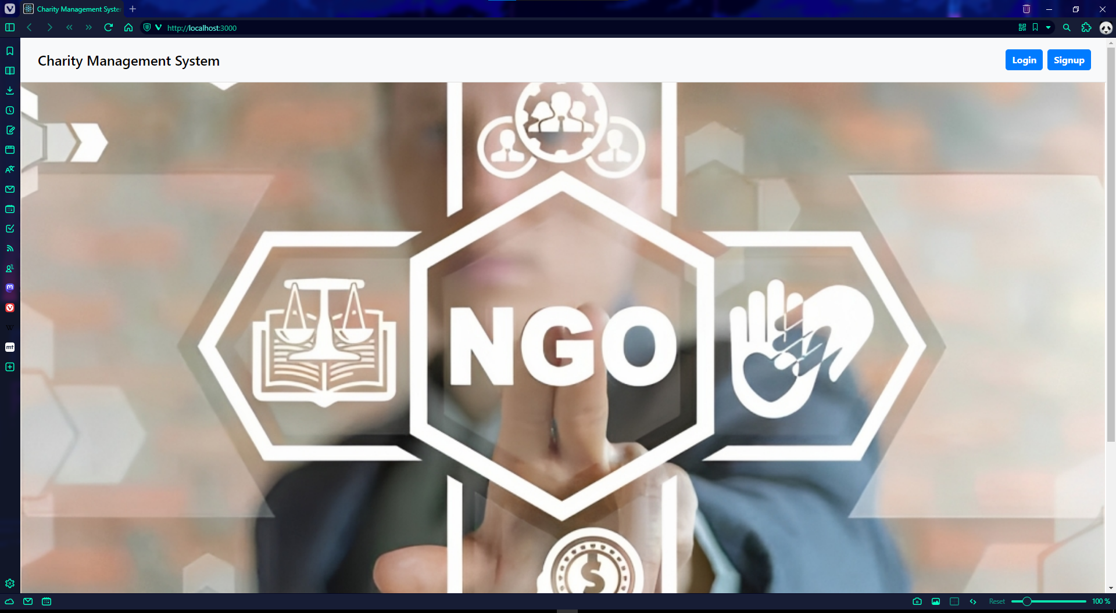

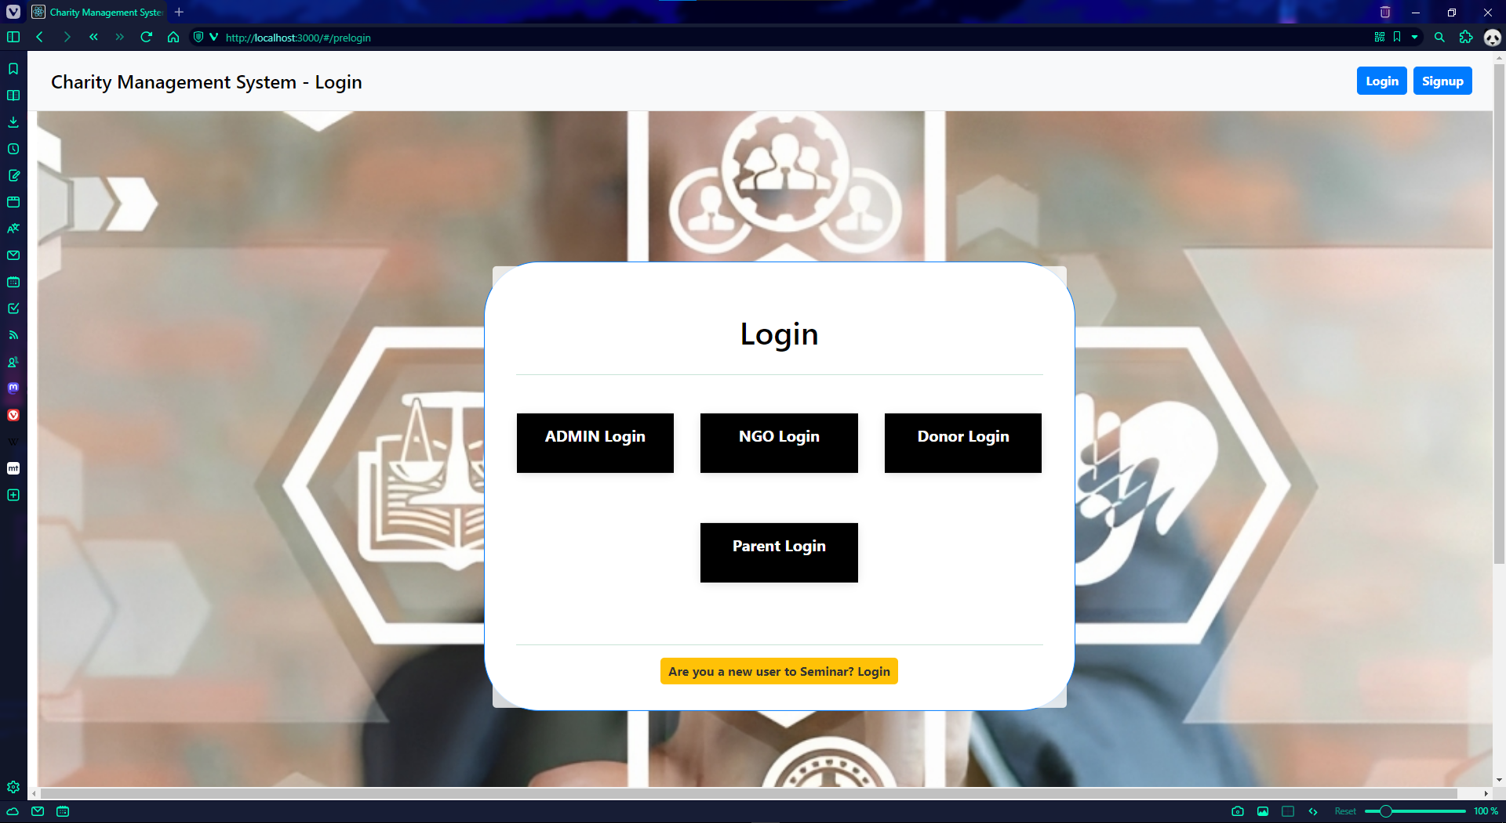**Login and Sign-up Page**

7. User Interaction

//Text Here

Future Work

//Text Here

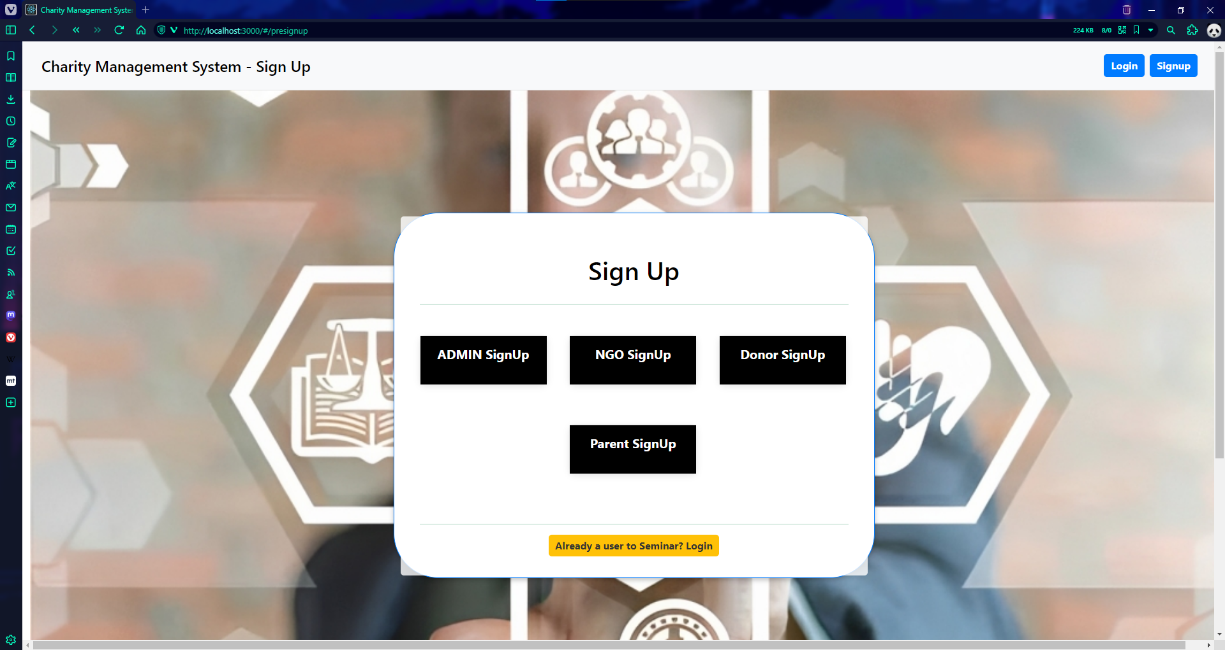Mini Project Plan

//Text Here

Conclusion

//Text Here

References

//Text Here

**Admin Sign-up Page**

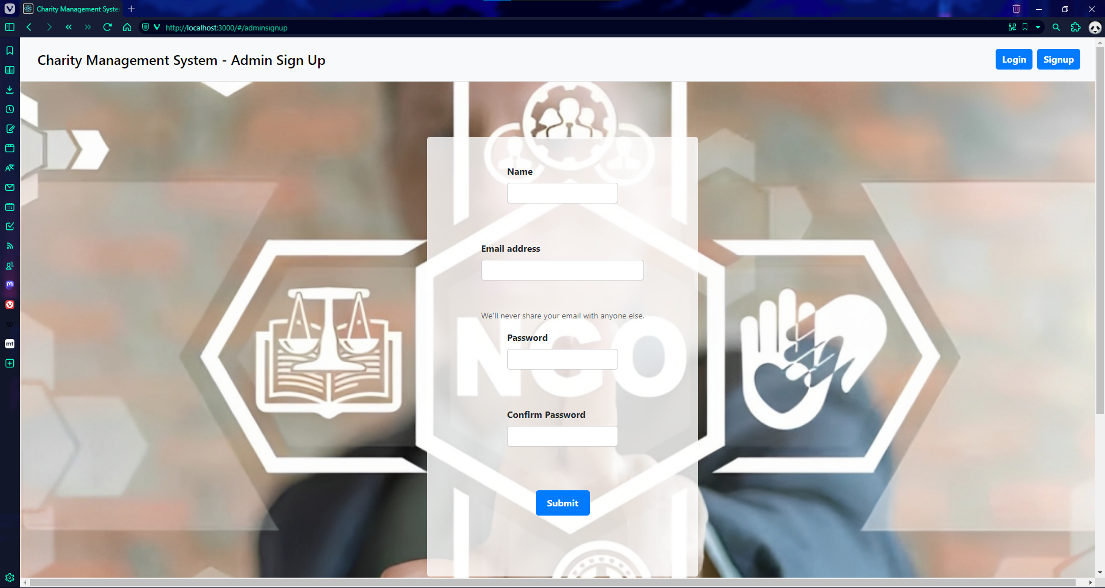

**Admin Login Page**

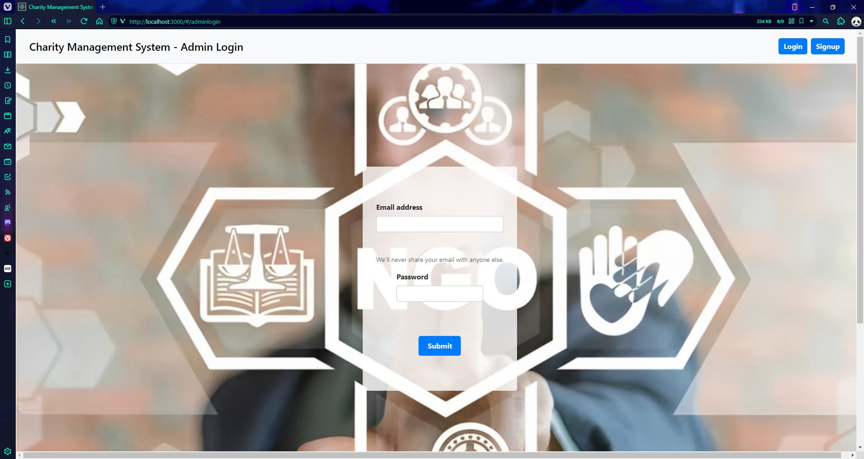

Conclusion

The Child Adoption Management System project aims to streamline and facilitate the process of child adoption through NGOs. By implementing user registration and login functionalities for Admin, NGOs, Donors, and Parents, the system provides a centralized platform for efficient collaboration and interaction.

The project enables NGOs to upload comprehensive child information, which can be reviewed and approved by the Admin. Donors can contribute financially to support the children's welfare, and parents can search for suitable children and initiate the adoption process.

Through the use of modern technologies such as React for the front-end and SQL for the back-end, the project ensures a user-friendly interface, robust data management, and security measures to protect sensitive information.

By developing this Child Adoption Management System, we aim to simplify the adoption process, promote transparency, and connect donors and parents with NGOs efficiently. It is our hope that this system will contribute to the well-being and future of children in need of loving homes, fostering a culture of compassion and support within our society.

References

***Title: "The Power of Adoption: Transforming Lives and Creating Families"***

***Reference: Smith, J. (2018). The Power of Adoption: Transforming Lives and Creating Families. Adoption Quarterly, 21(3), 197-210.***

Summary: This article explores the transformative power of adoption in changing the lives of children and creating loving families. It emphasizes the importance of adoption as a means of providing a stable and nurturing environment for children in need.

***Title: "The Role of NGOs in Child Adoption: A Case Study of Successful Adoption Programs"***

***Reference: Johnson, L. (2020). The Role of NGOs in Child Adoption: A Case Study of Successful Adoption Programs. Journal of Social Services Research, 46(2), 123-138.***

Summary: This case study examines the crucial role of NGOs in facilitating child adoption processes. It highlights successful adoption programs implemented by NGOs, emphasizing their impact on improving the lives of children and connecting them with loving families.

***Title: "Building a Culture of Compassion: The Importance of Charitable Organizations in Society"***

***Reference: Williams, A. (2019). Building a Culture of Compassion: The Importance of Charitable Organizations in Society. Journal of Nonprofit & Public Sector Marketing, 31(2), 168-184.***

Summary: This article explores the significance of charitable organizations in fostering a culture of compassion in society. It highlights the role of NGOs in providing support and assistance to vulnerable populations, including children in need of adoption, and emphasizes the positive impact they have on society.

***Title: "The Transformative Power of Donations: Inspiring Change and Making a Difference"***

***Reference: Roberts, M. (2017). The Transformative Power of Donations: Inspiring Change and Making a Difference. Journal of Philanthropy, 25(3), 213-228.***

Summary: This journal article discusses the transformative power of donations and the impact they can have on creating positive change. It emphasizes the role of donors in supporting charitable initiatives, such as child adoption, and highlights the significance of their contributions in making a difference in the lives of children and families.

***Title: "Adoption: A Journey of Love and Hope"***

***Reference: Thompson, R. (2021). Adoption: A Journey of Love and Hope. Adoption Today, 23(4), 45-58.***

Summary: This article presents adoption as a journey filled with love and hope. It explores the emotional aspects of the adoption process for both children and adoptive parents, highlighting the transformative power of providing a loving and nurturing home to a child in need.